**Enhancing Online Safety: A Browser Extension for Adult Content Detection**

KAMATE KATENDE TIMOTHEE

[kamatekatende@gmail.com](mailto:kamatekatende@gmail.com), [tim58841@gmail.com](mailto:tim58841@gmail.com)

**202312051**

MSIS/Y1/W

**Abstract:**

This research paper explores the development and implementation of a browser extension designed to enhance online safety by detecting adult content on websites that may not be immediately apparent. The extension, activated by a user upon visiting a webpage, analyzes the site's content and sends a notification if adult or explicit material is detected. This paper outlines the motivation behind creating such an extension, the methodology employed for content analysis, the implementation details, and the results of the extension in action. The research discusses the significance of this tool for safeguarding children and individuals seeking protection from adult content, contributing to a safer online environment.

**Key-words:** Online Safety, Browser Extension, Adult Content Detection, Internet Security, Chrome Browser

1. **Introduction:**
   1. **Problem background**

A growing body of research shows repeated and prolonged use of social media platforms by young people has been shown to increase, depression, anxiety, sleep deprivation, and expose children to harassment, bullying, sexual predators.[1] The internet serves as a vast repository of information and entertainment, making it an essential resource for users of all ages. However, the accessibility of explicit or adult content poses risks, especially for children or individuals seeking to avoid such material. This research introduces a browser extension designed to address this concern by providing an additional layer of protection through on-the-fly content analysis.

People search for the data according to their interest. But sometimes along with desired data some others content can come up which may have no relevance with the original data. Pornography and violent images can fall under this category. With the increasing rate of advertisements on every kind of page these types of content are becoming more available to the viewers. Especially the children since they are the most vulnerable. They watch whatever content comes in front of them in any platform. Because of the increasing rate of pornography, in recent times parental control has been necessary. And to help them the demand for automatic detection of pornography and violent images is continuously rising. Also, there is the threat for malware which comes along with the pornography content.[2]

The current systems are based in machine learning algorithm focusing on images, but there are many websites which contains those unwanted links to adult content like pornography. Our system will be detecting them.

* 1. **Objectif of the work**

The proposed research aims mainly at designing and implementing a Chrome web browser extension that will be checking for adult content based on the content of the web page. It will be sending notification of the result; thus, it will help prevent adult content.

* 1. **Scope**

Our proposed research is limited to Chrome browser and our algorithm is limited to regex expression search based on the content. Due to the one-week timing, we will not be adding many features like automatic detection and blocking of the adult content neither reporting to the backend the number of adult contents found. We will limit on checking content, URL and sending notifications.

* 1. **Motivation**

**Did you know that one in three internet users in the world is a child? Worldwide, young people were 1.24 times more likely to be connected than the rest of the population.[3]**

The motivation behind developing the browser extension for adult content detection is multifaceted and crucial for ensuring a safer online environment. Here are some key motivational points:

1. **Protecting Vulnerable Users:** The primary motivation stems from the need to safeguard vulnerable users, especially children, from stumbling upon explicit or adult content unintentionally. With the increasing prevalence of such material online, there is a pressing need for tools that can provide an additional layer of protection.

2. **Addressing the Rise in Explicit Content:** As the internet becomes a more significant part of our lives, the accessibility of explicit content also increases. The research recognizes the challenges posed by the rising rates of explicit material, particularly in the form of advertisements on various web pages. This extension aims to address this issue by identifying and notifying users about potentially harmful content.

3. **Parental Control and Online Safety**: The motivation extends to the necessity of parental control in the digital age. With children being exposed to online content indiscriminately, there is an urgent need for tools that empower parents and guardians to control and monitor the online experiences of their wards. The browser extension contributes to this parental control by detecting and notifying about adult content.

4. **Mitigating Malware Threats:** Beyond explicit content, the motivation includes recognizing the potential threat of malware that often accompanies adult content. By identifying and alerting users about the presence of such content, the extension plays a role in enhancing overall online safety.

5. **Improving User Experience:** The motivation also revolves around enhancing the overall user experience by allowing individuals to browse the internet without the fear of encountering inappropriate content. This contributes to creating a more positive and secure online environment for users of all ages.

1. **Literature Review:**

Existing literature highlights the prevalence of adult content online and the potential risks associated with unrestricted access, particularly for children and young users. Various content filtering tools and parental control solutions have been proposed and implemented, yet gaps persist in effectively detecting explicit content on websites that might not be flagged by conventional means. This paper reviews current approaches, challenges, and gaps in content filtering technologies.

**Methodology:**

We used regex expression for checking the content of the page.

**Adult Content Pattern:**

javascript

**const contentRestrictedPattern = /(?:porn|adult content|age\s*restricted\s*18)/i;**

This pattern checks for keywords related to adult content, such as "porn," "adult content," or phrases indicating age-restricted material. It's important to note that these regular expressions provide a basic level of pattern matching and may not cover all possible variations or be foolproof. For more advanced and accurate content analysis, machine learning models or external services designed for content filtering and detection might be considered.

1. **Implementation:**

We implemented our system in JavaScript and HTML, CSS and bootstrap for the design.

*Popup.html*

<!DOCTYPE html>

<html lang="en">

<head>

    <meta charset="UTF-8">

    <meta name="viewport" content="width=device-width, initial-scale=1.0">

    <title>XDetector</title>

    <!-- Include Bootstrap and jQuery locally -->

  <!-- Include Bootstrap and jQuery locally -->

  <script src="bootstrap/js/jquery-3.2.1.slim.min.js"></script>

  <script src="bootstrap/js/popper.min.js"></script>

  <link rel="stylesheet" href="bootstrap/css/bootstrap.min.css">

  <script src="bootstrap/js/bootstrap.min.js"></script>

    <script src="popup.js"></script>

    <style>

        body {

            padding: 20px;

        }

        #banner {

            background-color: #007bff;

            color: white;

            text-align: center;

            padding: 10px;

            margin-bottom: 20px;

        }

        #saveCodeBtn {

            display: block;

            margin: 0 auto;

            padding: 10px 20px;

            font-size: 18px;

            background-color: #007bff;

            color: white;

            border: none;

            cursor: pointer;

        }

        #saveCodeBtn:hover {

            background-color: #0056b3;

        }

    </style>

</head>

<body>

    <div id="banner">

        <h1>XDetector</h1>

        <p>Your safeguard against adult content</p>

        <p>Designed by Timothee Katende | Email: kamatekatende@gmail.com</p>

    </div>

    <button id="saveCodeBtn">Check content</button>

</body>

</html>

*Popup.js*

// popup.js

// Wait for the DOM to be fully loaded

// document.addEventListener("DOMContentLoaded", function () {

//     // Find the button with the ID "saveCodeBtn" and add a click event listener

//     document.getElementById("saveCodeBtn").addEventListener("click", function () {

//         // Trigger the background script to save the code

//         chrome.runtime.sendMessage({ action: "saveCode" });

//     });

// });

// popup.js

// Wait for the DOM to be fully loaded

document.addEventListener("DOMContentLoaded", function () {

    // Find the button with the ID "saveCodeBtn" and add a click event listener

    document.getElementById("saveCodeBtn").addEventListener("click", function () {

        // Get the current active tab

        chrome.tabs.query({ active: true, currentWindow: true }, function (tabs) {

            const activeTab = tabs[0];

            // Fetch the source code of the current active tab

            chrome.scripting.executeScript({

                target: { tabId: activeTab.id },

                function: function () {

                    return document.documentElement.outerHTML;

                },

            }, function (result) {

                if (chrome.runtime.lastError) {

                    console.error(chrome.runtime.lastError);

                } else {

                    // Send the source code to the background script

                    const sourceCode = result[0];

                    chrome.runtime.sendMessage({ action: "saveCode", sourceCode });

                }

            });

        });

    });

});

**Screenshots**

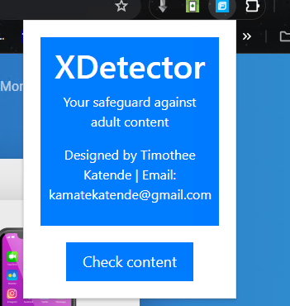

**Results:**

The results section presents findings from testing the extension on a variety of websites with different content types. It highlights the extension's effectiveness in detecting adult content, as well as potential challenges faced during the testing phase.

Our extension has been tested on picaf.com, no adult content found:

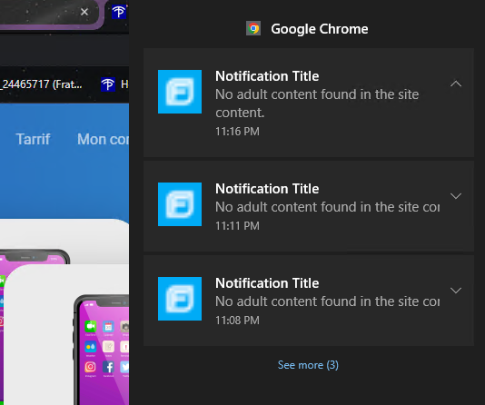

I developed a simple html page with url containing porn.test domain, it detected adult content:

\

<!DOCTYPE html>

<html>

    <head>

        <Title>Porn Testing</Title>

    </head>

    <body>

        <a href="porno.com">Click here</a>

    </body>

</html>

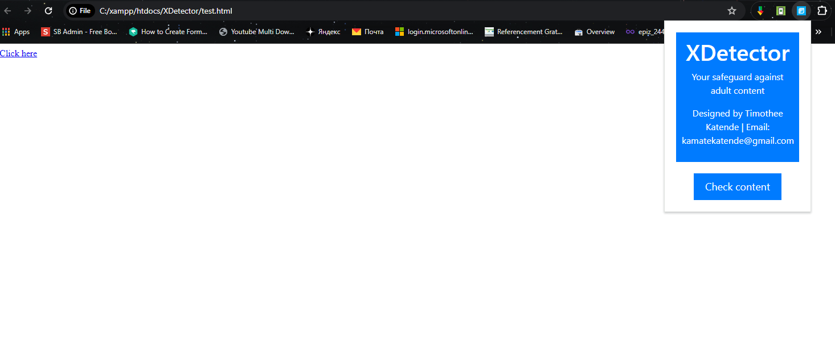

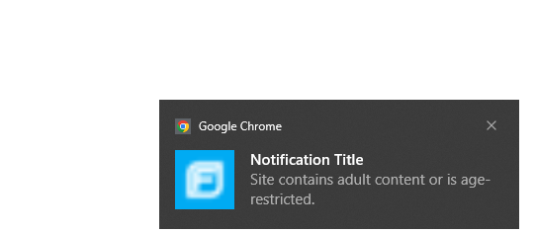

1. **Discussion:**

This discussion section interprets the results, considering the implications of the extension for users, parents, and online safety advocates. It addresses potential limitations, such as false positives or evolving content types that may evade detection. The discussion also explores the extension's role in promoting responsible internet use and the challenges associated with maintaining an up-to-date content analysis mechanism.

Firs of all, many websites may appear legitimate without adult contains but when clicking on the URL the user gets redirected to adult content. We tested that; the site appearance was not having any adult image content. But the URL redirected to wrong site, so the extension detected that.

There are false positive when the browser checks a legitimate site, but that contains key word like porno, because in our algorithm we restricted that no legitimate site should contain such words.

This extension will help prevent navigating to website that would guide to adult content.

**Conclusion:**

In conclusion, this research has successfully developed and implemented a browser extension aimed at enhancing online safety by detecting adult content on websites. The extension's effectiveness was evident in identifying potential threats, even when the site's appearance seemed innocuous. The capability to detect redirects to adult content, as demonstrated in our testing, underlines the extension's significance in providing an additional layer of protection for users.

While acknowledging the occasional false positives, particularly when legitimate sites contain specific keywords, the extension proved valuable in preventing users from navigating to websites that could lead to adult content. The findings underscore the importance of such tools in promoting responsible internet use and addressing the challenges associated with deceptive URLs and evolving content types.

The browser extension presented in this research stands as a proactive measure in fostering a safer online environment, especially for vulnerable users. Its role in mitigating the risks associated with adult content and deceptive URLs contributes significantly to the broader discourse on online safety.

**Future Work:**

Looking ahead, there are several avenues for future work and improvements to the browser extension. One potential direction involves incorporating machine learning models to enhance content analysis. This could enable a more sophisticated and adaptive approach, reducing false positives and keeping pace with evolving online content.

Improving the user interface of the extension is another area for future development. A more user-friendly interface would enhance the overall experience, making it more accessible and intuitive for users of varying technical backgrounds.

Additionally, exploring collaborations with internet service providers (ISPs) could lead to broader implementation and impact. By integrating the extension at the ISP level, a more comprehensive and network-wide approach to online safety could be achieved.

**References:**

Restrepo et al., Problematic Internet Use in Children and Adolescents: Associations with Psychiatric Disorders and Impairment, 20 BMC Psychiatry 252, (2020), <https://doi.org/10.1186/s12888-020-02640-x>.

Child Safe Browser Extension: A Browser Extension to Detect Adultery and Violent Content to Make Safer Web for Children by Md. Alhossen 16301207 Rafika Zannat Himi 17201102 Zahid Hasan 16201028, 2021

**Webography**

Child safety online, https://dig.watch/topics/child-safety-online

**Appendices**

Microsoft Global Online Safety survey

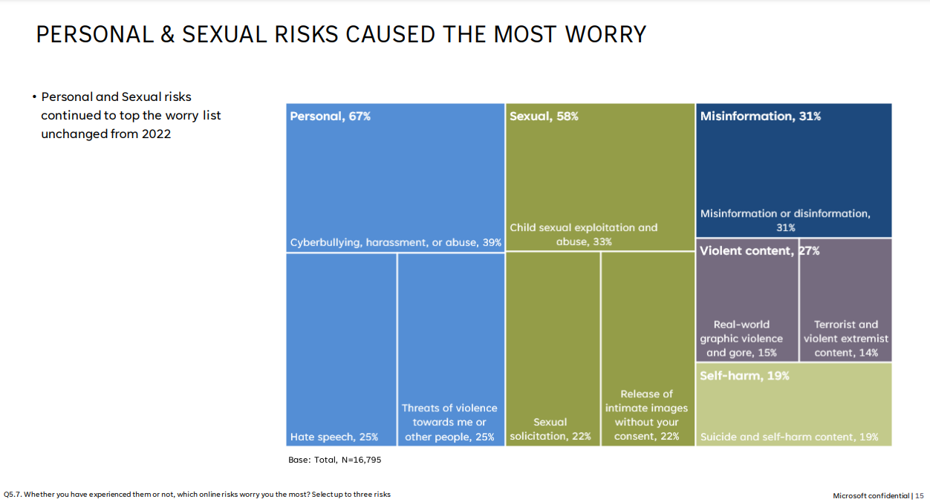

Source: <https://news.microsoft.com/wp-content/uploads/prod/sites/40/2024/02/Microsoft-Global-Online-Safety-Survey-2024.pdf>, page 15

1. Restrepo et al., Problematic Internet Use in Children and Adolescents: Associations with Psychiatric Disorders and

   Impairment, 20 BMC Psychiatry 252, (2020), https://doi.org/10.1186/s12888-020-02640-x.
2. Child Safe Browser Extension: A Browser Extension to Detect Adultery and Violent Content to Make Safer Web for Children by Md. Alhossen 16301207 Rafika Zannat Himi 17201102 Zahid Hasan 16201028, 2021
3. Child safety online, https://dig.watch/topics/child-safety-online